A cost effective and secure digital voting system using biometric features and cloud computing technology: Bangladesh perspective

Syful Islam, Ratnadip Kuri, Abhijit Charaborty, Md. Javed Hossain, Dr. M.H kabir
Lecturer, Lecturer, Asst. Professor, Associate Professor, Professor
Noakhali Science and Technology University
Email:syfulcste@gmail.com

Abstract: Nowadays Voting data security, accuracy with cost efficiency are the most talked topics in our modern society since it's a prime factor for reflecting public opinion in any electoral process of a democratic country. There are very few proposals exist that emphasize on data security and cost efficiency of voting systems. The main purpose of our strategy is to propose a highly secure digital voting system, incorporated with cloud based computing and biometric features that will help to perform not only a fair election but also create more authentication, transparency & security in voting system which will be an appealing step of digitizing Bangladesh.

Keywords: Data security, Accuracy, Cost effectiveness, Digital Voting system.

INTRODUCTION
Bangladesh, one of the most densely populated countries in the world. Hence, the creation of an accurate voter database has been a massive task. In 2008, the government of Bangladesh launched voter registration process to facilitate identity card with photograph to ensure transparent election. But this initiative failed to meet hope and caused a huge possibility of fake voting with allegations of a large number of fake voters in the electoral process [1]. Then during the period of the caretaker government, the Election Commission (EC) developed an electronic database of more than 80 million voters contained photographs and fingerprints [1].This initiative introduced electronic voting machine (EVM) for creating a new dimension in the electoral process of Bangladesh. EVM was first used partially in Chittagong City Corporation (ChCC) election in 2010 and then in Narayanganj City Corporation (NCC) election in 2011 with hopes of introducing it in the national election [2].Since EVM machine contains a memory chip and a removable memory card. So it has still some potential security problem in case of memory damage or lost by polling officers. Finally, ECB has decided to upgraded its biometric identification that stores voter information such as fingerprints, photos, signatures and contact details for approximately 89 million Bangladeshi voters and the consequent result is National ID(NID) card has taken the form of a Smart card[3]. The interesting matter is implementation of smartcard technology, open new door of fair election process.

Background
Many researchers from different countries performed research on transparent voting system using different technologies summarized in table (1) shown below. Currently, there is no proposal of voting system to support the features and objectives of smart card to improve current voting situation in Bangladesh. Now it’s time being demanding higher standards of voting process, fair result, more participation for proper reflection of public opinion in any electoral process of Bangladesh.
Table 1: Summary of different proposed voting system
Paper S.I No. | Pub-  Year | Technical Summary | Technology
Paper S.I No. | Pub-  Year | Technical Summary | Biome-  trics | Other  Security  features | Cloud Technology
[4] | 2013 | E-voting with embedded security | Yes | No | No
[5] | 2013 | Secure online voting system | Partial | Yes | No
[6] | 2013 | EVM technology using fingerprint | Yes | No | No
[7] | 2014 | Functional encryption based voting scheme | Partial | Encryption | No
[8] | 2014 | Ring signature based e-voting | No | Ring  protocol | No
[9] | 2014 | Cloud-based integrated voting system | Partial | I-voting | Yes
[10] | 2015 | Biometric Cloud Computing Integration with virtual server application | Yes | No | Yes(Not  clearly  specified)
[11] | 2016 | E-voting based on digital signature and cryptographic scheme. | No | Crypto-  graphic Schemes | Web service  (Type  not specified)
[12] | 2017 | E-voting with preserving anonymity system | No | Non-  repudiation | No

Proposed System Model
Figure. 1 depicts a general model architecture of our proposed system, for conducting efficient and credible elections in Bangladesh. The mechanism is designed to record votes by means of ballot display with LCD screen that can be activated by the voters, typically by push button or touch screen; processes vote’s data by means of a computer program and records them in central database. The system will be interlinked with a highly secured network that allows for quick and accurate voting electronically. It uses a client/server method which allows voters to cast ballots on the client terminal. Each client interfaces with the central server, which keeps track of the entire system. The voting process involves eligible voter’s biometric registration, secure authentication, voting and tallying with verification. The intended voter upon registration will receive a smart card with his or her bio-data, fingerprint and photograph printed on it to be used during authentication and voting on the Election Day. In the design, only the central authorized administrator has access to the central database/server. In the proposed system, voters can mark their votes directly into an electronic device, using a touch screen or push buttons devices with fingerprint capturing capacity when voting. The voting terminals are connected via a dedicated network to the central cloud machine for recording votes as they are casted.
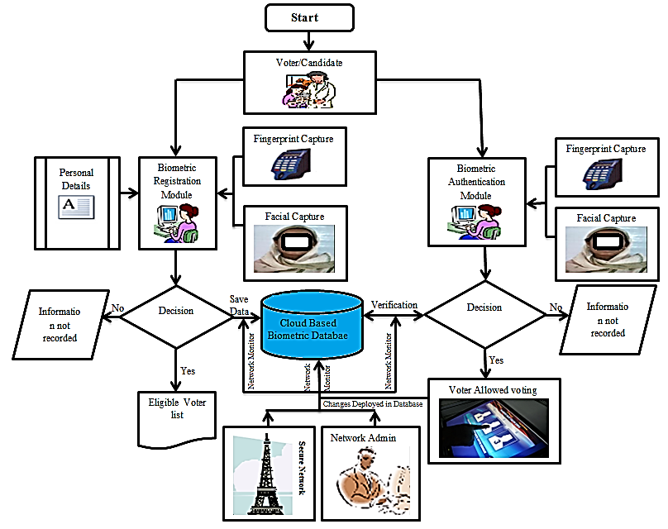
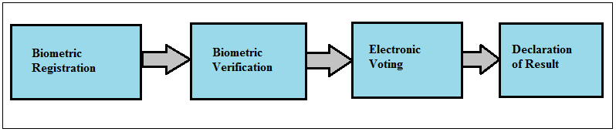Fig 1: Diagram of Biometric (Digital) voting architecture

Methodology of the proposed system

Biometric Registration of the voter and candidates
Figure. 2 describes the sequence diagram of voter/candidate registration process This involves the process of capturing an eligible (18 years of age or above, with a sound mind, a national and resident in the country) voter’s (Name, Date of Birth, Home town, Language, Address, Family, Passport. photograph, etc.) and candidates (Name of Candidate, Party Name and Logo if applicable, portfolio or position vying) personal information including fingerprints using the fingerprint machine to scan the fingers and stored to the voter’s database that will be used for authentication or verification on election day.

Biometric Verification
A fingerprint and facial recognition system will operate either in verification mode or in identification mode. The stages that will require in a fingerprint and facial verification system are shown in Figure (3). Initially, feature extraction block, begin with a normalization of the segmented iris image. Here normalization becomes necessary since we consider that the pupil varies in size for different light intensities. This normalization method changes the polar coordinate system, considering a virtual line drawn around the pupil, known as the iris signature. After normalization phase the information is cleaned up by applying different Gabor filters. This is then followed by the codification of this information in terms of the quadrant and perform the extraction using Gaussian filters by obtaining several images of different scales for posterior comparison. The Template Generation Module, based on Mega-Matcher Client, reads the WSQ images from the Oracle database and generates fused face and fingerprint templates that are then stored in a cloud based oracle database server. Mega-Matcher then uses these templates to carry out the biometric “N-to-N” matching process that identifies duplicates within the database records. Here “Face then fuse” technique is used. The system first generates face score, and if the score crosses the threshold value then the respective finger template is matched. Due to the high speed of the Mega-Matcher Fingerprint, face and iris matching algorithm [13], this method will significantly shrink the amount of time required to identify identical entries.

Digital Voting
When the voter will enter into the voting place, he/she must have same kind of valid identity, which was stored in the database for Verification during voter registration process. An authorized person will present in the booth to check the voter’s identity. There will be two conditions for valid identity Verification to allow polling section system that will be implemented as shown in Figure (4). When a poll worker confirms that the voter is considered as registered using smart card module (finger print& face matched to database), if matching found means this person is valid for voting otherwise the system will automatically close voting screen site. In this case if a person tries to vote multiple time by pressing, the system will automatically detect duplicate voting by fingerprint matching technique. Thus duplicate and fraudulent voting will be completely eliminated. The sequence diagram given below in Fig. 5 will further clarify the voting system:
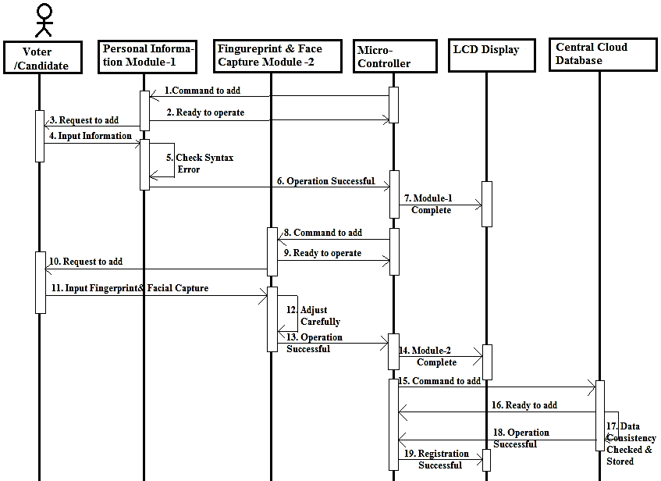
Fig 2: Sequence diagram of voter & Candidate registration

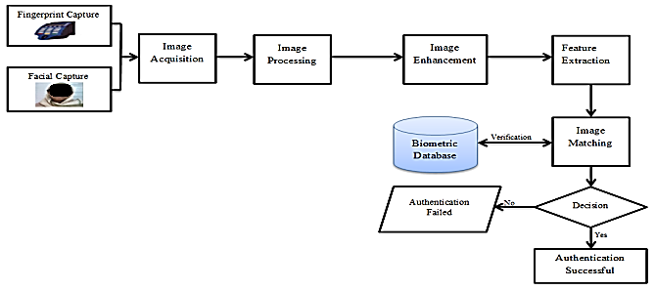
Fig 3: Flow diagram of Biometric Verification System
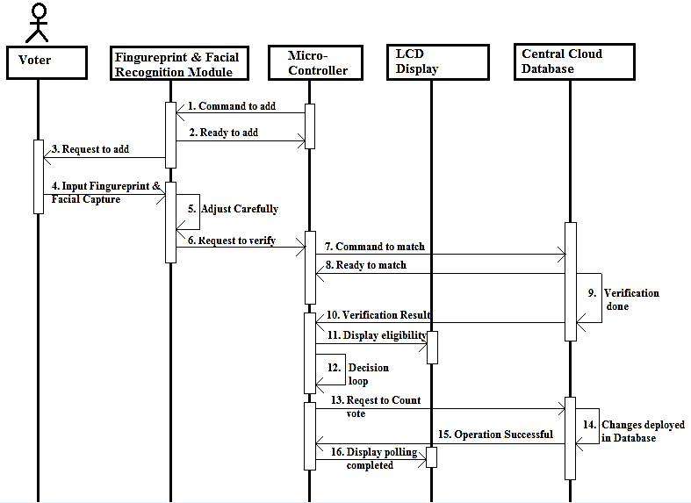
Fig 4: Sequence diagram of digital voting process

Vote Counting and Collection of Results
While voting is in progress, the software will create tally summary of each candidate’s votes as and when an eligible voter selects the candidate by touching the passport size photograph, Name of the candidate or the logo if applicable. The percentage of vote cast by each candidate will be calculated and their respective positions determined as soon as polls closes. The voting software will display the results after the elections by the electoral official as shown in Figure (5&6). below:
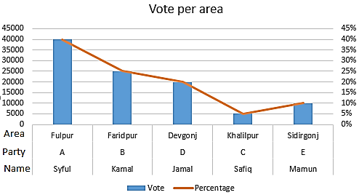
Fig 5: Result of vote per area
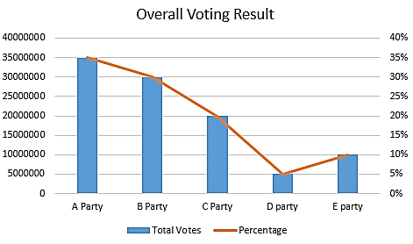
Fig 6: Overall voting result

Discussion
- Our proposed system is quite unique from EVM (Electronic voting machine). Generally, EVM system use fingerprint technique for counting vote but our system use two step authentication technique for more secure and transparent voting. First the voter must have to punch his smart card to ensure the card holder is an eligible voter. Then if match found with data retrieved from cloud central database the second screen of voting will be appeared in the screen. In the second step, the voter will select or touch the candidate on the screen. Here the fingerprint of the voter will have tried to match with the information stored in the central database. If match found the vote will be counted. Here, fingerprint feature is used to ensure that the voter touches the screen to vote. If the voter will again try to vote on the same center or in the other center, the voter fingerprint will act as information to eliminate the duplicate voting problem.
- In case of adverse situation, the voting result of a particular center can be manipulated or stolen by removing the memory card of the EVM. And this case already happened in Bangladesh. But in our proposed system the voting result will be stored in the central cloud database. Moreover, in order to avoid exceptional case of memory damage, the voting result will be stored in multiple database at the same time. This is the unique advantage of cloud computing platform.
- EVM system generally require many machine dedicated for an area if the area has many voting center. Thus it requires a huge initial cost to buy EVM machine. But our system is a distributed system where in the voting center will only require voting interface screen with smart card punching facility and internet to connect with the central cloud server. The implementation of our system will require just one-time investment. And this will be very cost efficient adoption.
- Here we propose the use of cloud server dui to its huge parallel processing capabilities and it will increase the grade of service of our voting system although it is third party intervention. So for more transparency, we must have to ensure a strong agreement with cloud server holder. If possible our system will be highly cost efficient.
- Our system will use cryptographic technique (Encryption/Decryption) to secure voting data for transmit and store in the central database. However, system may require a secure and dedicated network for voting to avoid network tampering or hacking in adverse condition. Besides, it will require dedicated bandwidth and continuous power supply for error free voting which is a big challenge for Bangladesh. Also Election commission of Bangladesh need to train people to adopt with new voting system. So, it will require some initial cost.

Conclusion
Currently, vote accuracy, security and confidentiality are crying need in any electoral process of Bangladesh. In addition, traditional paper based and EVM (electronic voting machine) voting system in Bangladesh has witness a lot of challenges to accomplish a fair election process. Our proposed voting systems willoffer many unique advantages (Summarized below) compared to other traditional voting techniques in perspective of Bangladesh.

Table 2: Comparison of existing system with our proposed system
Parameters | Proposed System | EVM  System | Ballot system
Reduce voting and counting errors? |  |  | 
Improved standardization of voting system? |  | (Partial)
Improved accessibility ? |  | (Partial)
Avoid adverse voting situations?
Potentially improved compliance through the implementation of soft stops?
Improved efficiency of many voting related processes? |  | (Partial)
Reduce the incidence of duplicate voter allegation?
Automatic audit trails and auditing? |  | (Partial)

Acknowledgment
We would like to thank our honorable supervisor Dr. Humayun Kabir, professor and Chairman; Md. Javed Hossain, Associate professor; Abhijit Chakraborty, Assistant professor, Dept. of Computer Science and Telecomunication Engineering.

REFERENCES

- Reuters Staff(July 23, 2008), “Bangladesh completes voter list to hold fair polls”, Available: https://www.reuters.com/article/idINIndia-34636020080723 . [Accessed 27 Nov. 2017]
- M. Mesbahuddin, SARKER1, M Nazrul, ISLAM2, “Management Of Sustainable, Credible And Integrated Electronic Voting (E-Voting) System For Bangladesh”, Management of Sustainable Development Sibiu, Romania, Volume 5, No.1, pp. 15-21, June 2013
- Enterprise Innovation editors (May 7, 2012), “Bangladesh Government upgrades biometric ID, voter registration system”, Available: https://www.enterpriseinnovation.net/article/bangladesh-government-upgrades-biometric-id-voter-registration-system. [Accessed 27 Nov. 2017]
- Alaguvel.R1, Gnanavel.G2, Jagadhambal.K3, “Biometrics using Electronic Voting System
with Embedded Security”, International Journal of Advanced Research in Computer
Engineering & Technology (IJARCET), Issue 3, March 2013, pp. ‘’.
- Srivatsan Sridharan, “Implementation of Authenticated and Secure Online Voting
System”, Computing, Communications and Networking Technologies (ICCCNT),IEEE, Tiruchengode, India, July 4 – 6, 2013.
- Sanjay Kumar1, Manpreet Singh2, “Deign a secure electronic voting system using fingerprint”, IJCSI International Journal of Computer Science Issues, Vol. 10, Issue 4, No 1, pp. 192-199, July 2013.
- Chen Yang, Lin You, “Multi-Input Functional Encryption based Electronic
Voting Scheme”, International Conference on P2P, Parallel, Grid, Cloud and Internet Computing , IEEE, Guangdong, China, Nov. 2014, pp.134-138.
- J. L. Tornos, J. L. Salazar, J. J. Piles, “An eVoting System Based on Ring Signatures”, Network Protocols and Algorithms, Vol. 6, No. 2, pp.38-54, 2014.
- Gurpreet Singh Matharu, Anju Mishra, “CIEVS: A Cloud-based Framework to Modernize the Indian Election Voting System”, International Conference on Computational Intelligence and Computing Research(ICCIC), IEEE, Coimbatore, India, Dec. 2014, pp.‘’.
- Chakraborti, Bratati, “E-Voting security system through Biometric Cloud Computing Integration with virtual server application”, European Journal of Academic Essays Vol. 2, No. 1, pp. 6-9, 2015.
- NitanKohli1, Himanshu Saurav*, "A Real Time E-Voting System: An Initiative towards Digital India", International Journal of Engineering Trends and Technology (IJETT), Vol. 35 No.3, pp. 101-107, May 2016.
- Isredza Rahmi A Hamid* “Preserving Anonymity in E-Voting System Using Voter Non Repudiation Oriented Scheme”, The 2nd International Conference on Applied Science and Technology, (ICAST’17), Kedah, Malaysia, April 2017, pp. 020017-1 - 020017-6.
- Neuro Technolohy(jan 29, 2007), “Fingerprint, face and iris matching engines tests”, Available: http://www.neurotechnology.com/megamatcher-algorithm-tests.html#tests_finger_face_iris. [Accessed 6 july, 2015]

About Authors:

Syful Islam He has received B.Sc(Eng.) in Computer Science and Telecommunication Engineering(CSTE) bearing CGPA: 3.92 in the department of CSTE at Noakhali Science and Technology University(NSTU), Sonapur, Noakhali-3814, Bangladesh. He is serving as a lecturer in the same department. Currently he is on study leave and pursuing his higher study in at Nara Institute of Science and technology, Nara, Japan. He has published several research paper in international scientific journals. His email address is : islam.syful.il4@is.naist.jp, syfulcste@gmail.com

Ratnadip Kuri He has received B.Sc(Eng.) in Computer Science and Telecommunication Engineering(CSTE) from the department of CSTE at Noakhali Science and Technology University(NSTU), Sonapur, Noakhali-3814, Bangladesh. He is serving as a lecturer in the same department. He has published several research paper in international scientific journals. His email address is : ratnadipk983@gmail.com

Abhijit Chakraborty He is serving as an assistant professor in the department of Computer Science and Telecommunication Engineering at Noakhali Science and Technology University, Sonapur, Noakhali-3814. Currently he is pursuing his higher study(phd) in USA. He has published several research paper in international scientific journals. His email address is: abhijit.cse@gmail.com

Md. Javed Hossain He is serving as an associate professor professor in the department of Computer Science and Telecommunication Engineering at Noakhali Science and Technology University, Sonapur, Noakhali-3814. He has published several research paper in international scientific journals. His email address is: abhijit.cse@gmail.com

M. H. Kabir He received B.Sc. (Honors) and M.Sc. degrees in 1993 and 1995 respectively from the Department of Applied Physics and Electronics, the University of Dhaka, Bangladesh. He got Ph.D. in system engineering from the department of Electrical and Electronic Engineering, Kitami Institute of Technology, Hokkaido, Japan. He was a Lecturer and an Assistant Professor in Computer Science and Information Technology, The University of Comilla, Bangladesh. He is working as a Professor and the head of the department of Computer Science and Telecommunication Engineering at Noakhali Science and Technology University, Sonapur, Noakhali-3814. His research work concerned about finding an acceptable procedure for ‘Transmission Loss Allocation’ in the deregulated power market. Now his research work concerns about developing communication protocols. His email address is : hkabir269@gmail.com

